Peter Haynes

Dr. Erin Martin

DTS 350

August 29, 2022

Case Study 1: Critiquing Visualizations

Source: <https://fivethirtyeight.com/features/when-republicans-talk-about-immigration-they-dont-just-mean-illegal-immigration/>

Review:

This visualization is from data conducted June 1-30, 2022, from 3,262 US Adults, and June 7-20, 2019, from 2,059 US adults. This visualization was created to show how the different political parties of the United States view legal immigration as well as the overall average of them. Out of the people who participated in this poll, 47% of the republicans say that legal immigration should decrease while only 16% of democrats have the same point of view. 47% of democrats believe legal immigration should stay the same compared to the 37% republican voters. Finally, 36% of democrats stated that immigration should increase in contrast to the 15% of republicans. This graph does a great job visualizing the data conducted from the surveys. It uses the years 2002, and 2019 and shows the trend of which each political party stance on legal immigration. The issue with the data and information is that is takes data from such a small pool of people. If the surveys wanted to be more accurate, a larger pool of people would help tremendously to grasp a feel on how each party views legal immigration.

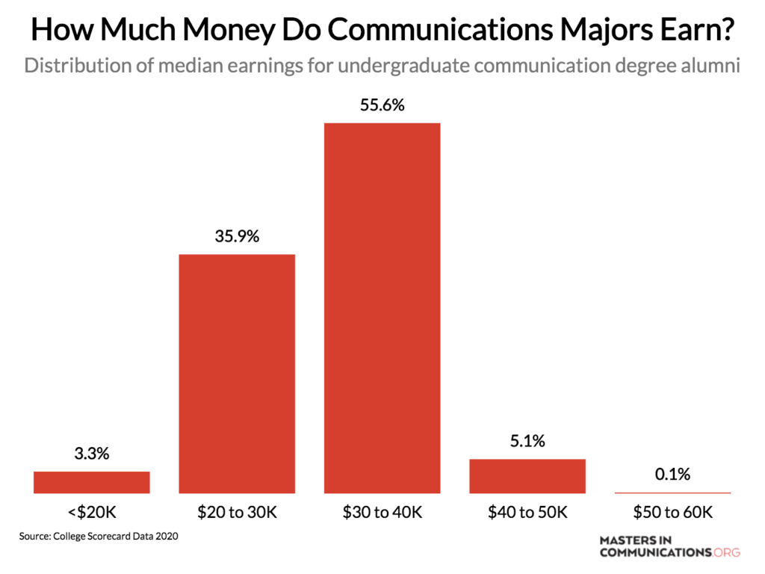

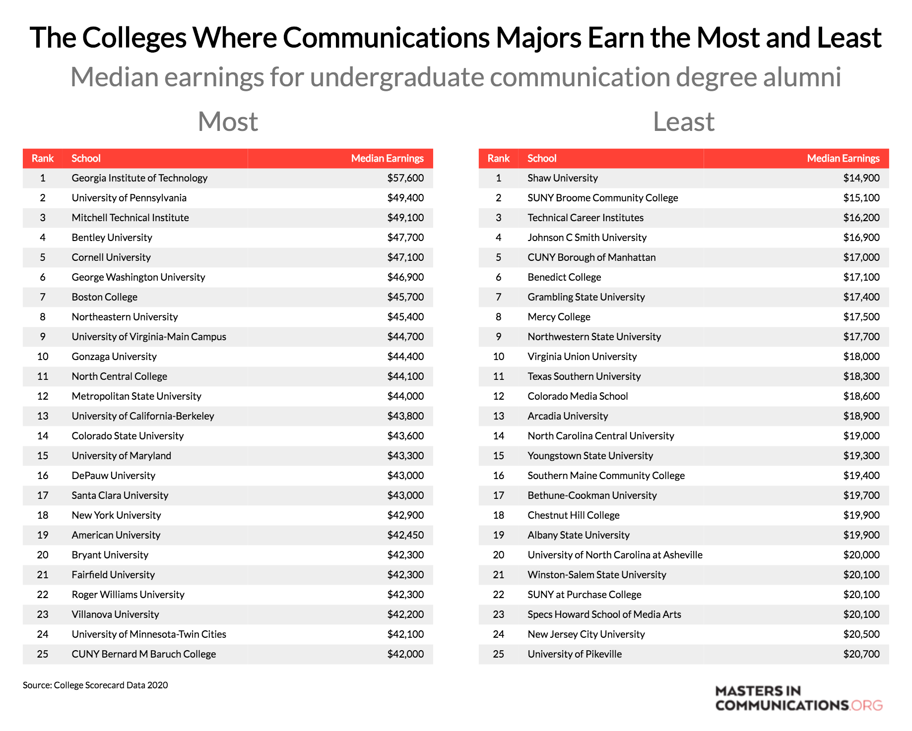

Source: <https://priceonomics.com/how-much-money-do-communications-majors-make/>

Review:

This article shows the correlation of students who major in communications degrees, and how much money they end up making after getting the degree. The median salary of a student with a communications degree is $31,400 in the United States. According to the first graph, you can see that nearly 95% of communication majors make less than $40,000 in the United States. This is a great and simple bar graph that allows viewers to visualize the data. The following graph used in this article dives into different universities around the country to find out where students go to make the most money and least money with their communications degree. As you can see from the chart, schools like UPENN and GA Tech median salaries are way above the industry average. Shaw University has the worst with their students earning a median of $14,900. The second to last graph shows what colleges provide their students with the least amount of debt. This is a fantastic chart that inform many people on what colleges are affordable for a communication degree. Finally, the last article shows the debt-to-income ratio for each college and their students that are alumni. This visualization can be critical for students

in the future that are pursuing a communication degree. Something that could make this visualization better is to know what information was used. For example, do students with scholarships that pay for most of their school count differently that a student that paid for the university with very limited financial help. Also, it does the factors of what information it chose from the College Scorecard. The charts in the article are very legible.

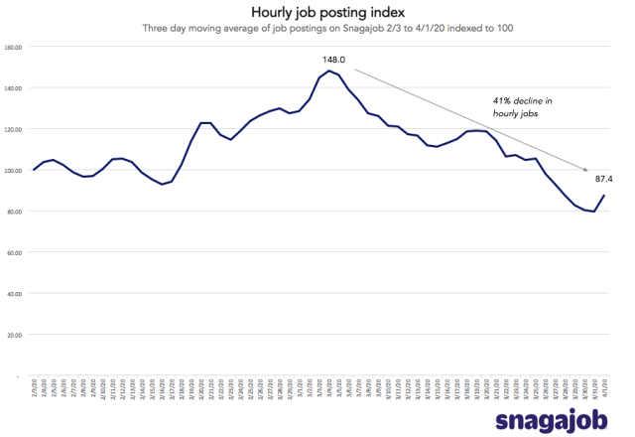

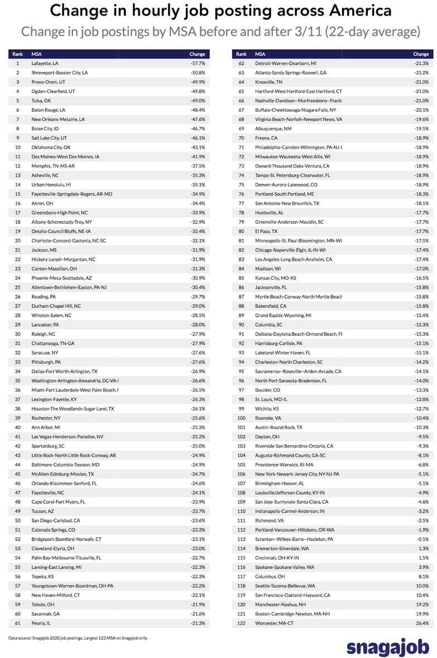

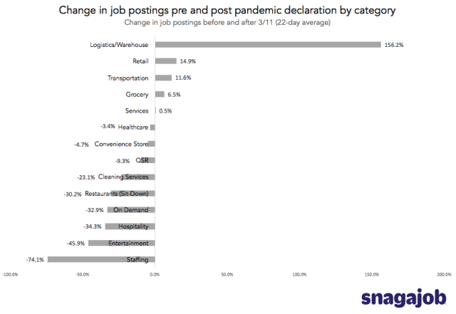

Source: <https://priceonomics.com/hourly-job-market-update-categories-where-jobs-are/>

Review: This article shows the effects of the coronavirus pandemic and shows what categories of jobs are available. When this article was published, job postings went down 40% from the peak that was the previous month (March). The first visualization interprets data that allows the viewers to see this 40% decrease in related to the job postings found on Snagajob. The second graph portrays valuable information that can be very beneficial for people looking for jobs in a specific industry. Jobs at Logistics/Warehouses must have been depleted from the pandemic due to the 156.2% increase of job postings. 14.9% increase in jobs throughout retail while only 6.5% increase in job postings by grocery stores. However, there has been significant decline in job postings in convenience stores (-4.7%), -30.2% decline in restaurant job postings and a whopping -74.1% decrease in staffing. This provides many citizens throughout America to find a job within an industry that is suffering from the impacts of the pandemic and need employees in order to recover. The last graph in the article shows data from change in hourly job postings across cities in America, within a 22 day average. These visualizations provide excellent information that provides Americans with an opportunity to make money and support their family. The visualizations would be way more accurate in if they took data from indeed, glass door, and LinkedIn and combined them. I think the information given in this article is great, just lacks key information and is vague. For instance, does Snagajob filter out all of the job postings that were duplicates and fulfilled?

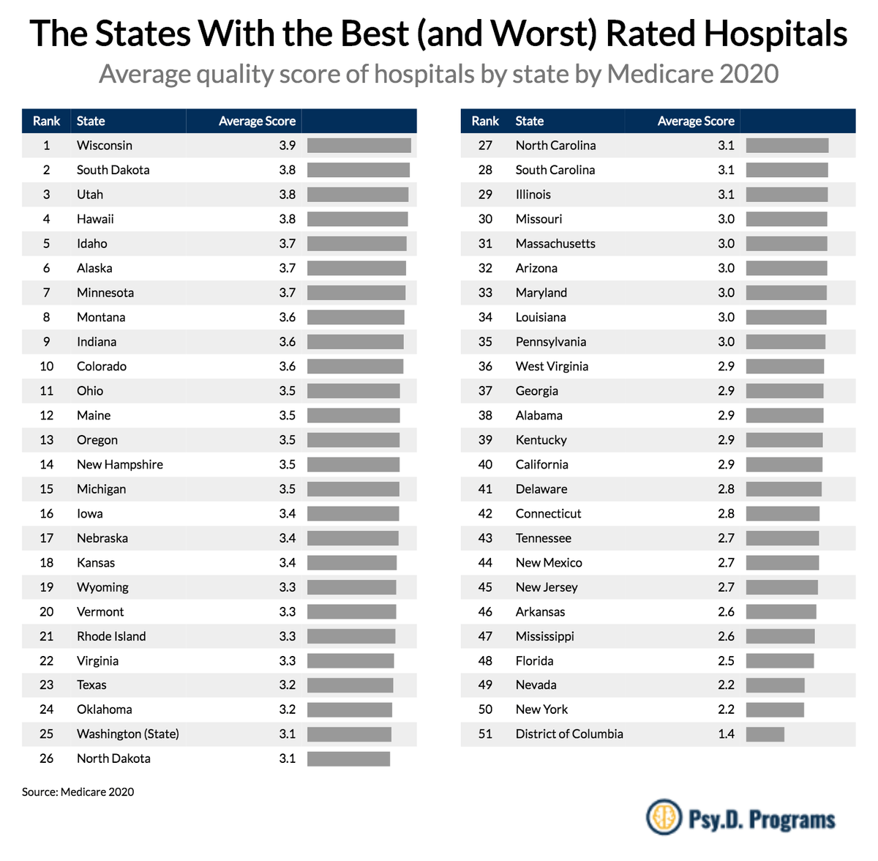

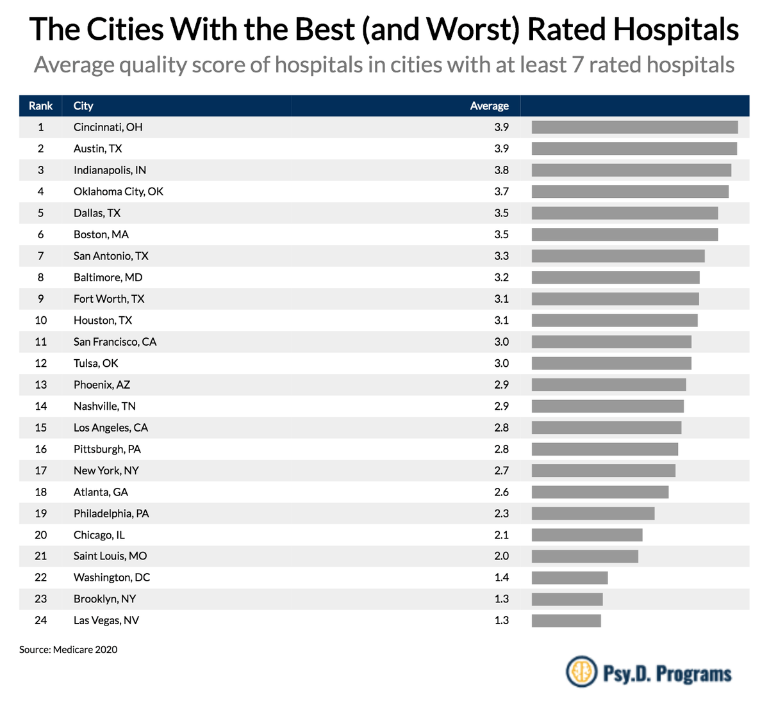

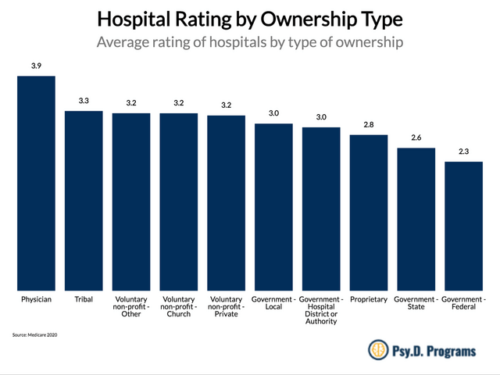

Source - <https://priceonomics.com/the-places-in-america-with-the-best-and-worst/>

Review: In America, it is very hard to measure to medical outcomes as well as the quality of healthcare. Out of many American that pass away every day, have you wondered how many deaths are from bad care or malpractice. The data provided in this article through visualizations is with people who have Medicare which is federally funded insurance for the elderly. The first graph provides data for the best and worst hospitals averaged in each state through a 1–5 star scale rating. The best state with hospitals is Wisconsin with an avg of 3.9 stars. While the worst hospitals in the United States according to the data are in New York with a 2.2 star rating. I think a great think that this article provides is that it dives deeper for information. The second graph provided in the article shows us the best and worst hospitals within cities. This is excellent as this article makes the elderly informed of which hospitals are rated the best in cities which can help with better care. The last visualization shows a bar chart of the rating of hospitals by the type of ownership. This again provides fantastic information on because it informs the people with Medicare that physician owned properties have the highest score with a 3.9 out of 5. This information could allow the elderly to be more informed about making the choice of what hospital to be seen at via the data and where the scores are the highest. However, as you can see in the graphs none of these states have above a 3.9 scale. This is concerning because it shows that the healthcare of the United States is average at best and many people are not satisfied with it. The last graph of the article is confusing because it doesn’t list the specific types of ownership that are within each column.